Shop Sales Data Report

Introduction
This report delves into a comprehensive sales dataset, analyzing sales performance and product trends among salesmen. It aims to uncover insights for sales strategy formulation and business enhancement. By examining sales data and comparing product performance, it identifies top salesmen, analyzes product popularity, and understands sales trends. These insights are invaluable for optimizing strategies and driving business growth.
Questionaries
1. Compare all the salesmen based on profit earn.
2. Find out most sold product over the period of May-September.
3. Find out which of the two product sold the most over the year Computer or Laptop?
4. Which item yield most average profit?
5. Find out average sales of all the products and compare them.
Analytics
Q 1. Compare all the salesmen on the basis of profit earn.
ANS: The comparison of all the salesmen on the basis of profit earned and the line chart shows that the rahul has the highest profit earned with value 493541.3255, compared to all the salesmen.
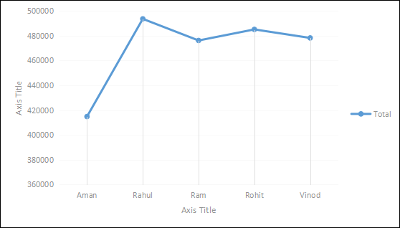

Q2. Find out most sold product over the period of May-September.
ANS: To pinpoint the most sold product from May to September, we analyze sales data within this time frame. Aggregating product quantities across all transactions reveals that the Laptop was the best-selling item, particularly in September, with sales totaling 280.1970249 units.
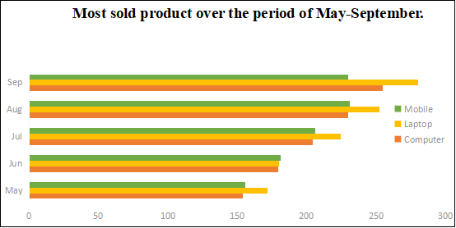

Q3. Find out which of the two product sold the most over the year Computer or Laptop?
ANS: Between computers and laptops, laptops were the best-selling product with 2,358.911786 units sold, compared to computers with 2,139.876313 sold over year.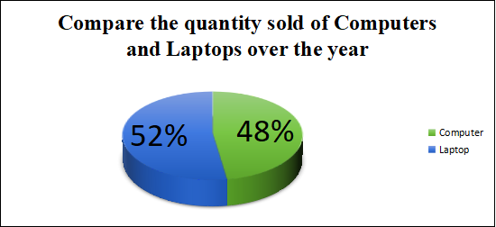

Q4 . Which item yield most average profit?
ANS: This analysis shows that the Mobile has the most Average profit earned among Mobile, Laptop, and Computer where Mobile has the average profit earned of 7057.58477.
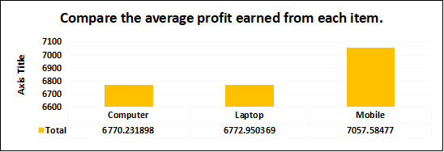

Q5. Find out average sales of all the products and compare them.
ANS: The analysis shows that the average sales quantity of Laptop(19.49513873) is higher than the other products e.g. Mobile(19.41876737) and Computer(19.45342103).

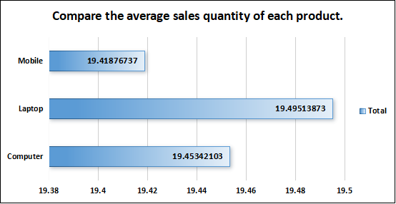

Conclusion and Review
The analysis uncovers crucial insights into sales performance and product trends among salesmen. Rahul emerges as the top performer, achieving the highest profit. The Laptop emerges as the best-selling product from May to September, with peak sales in September. Laptops outperform computers in units sold throughout the year. Mobile phones yield the highest average profit among devices, while laptops demonstrate the highest average sales quantity. Though providing valuable insights, deeper exploration into sales fluctuations and product preferences could enhance understanding. Overall, the report offers actionable insights for optimizing sales strategies and maximizing revenue, supported by visualizations aiding trend comprehension and product popularity assessment.
Correlation
The correlation coefficient between units sold and revenue is 0.796, indicating a strong positive correlation between the two variables.
 | Column 1 | Column 2
Column 1 | 1
Column 2 | 0.954077 | 1

Regression
The regression model, with a significant p-value indicates a strong positive relationship between Amount and the profit earned and the outcome variable. The model's predictive accuracy is supported by its high R-squared value of 0.910.
SUMMARY OUTPUT
Regression Statistics
Multiple R | 0.954076972
R Square | 0.910262868
Adjusted R Square | 0.909998936
Standard Error | 630.0595983
Observations | 342
ANOVA
 | df | SS | MS | F | Significance F
Regression | 1 | 1.37E+09 | 1.37E+09 | 3448.844 | 4.6E-180
Residual | 340 | 1.35E+08 | 396975.1
Total | 341 | 1.5E+09
 | Coefficients | Standard Error | t Stat | P-value | Lower 95% | Upper 95% | Lower 95.0% | Upper 95.0%
Intercept | 2068.993161 | 88.47952 | 23.38387 | 9.14E-73 | 1894.957 | 2243.029 | 1894.957 | 2243.029
X Variable 1 | 246.4655683 | 4.196812 | 58.72686 | 4.6E-180 | 238.2106 | 254.7206 | 238.2106 | 254.7206

Anova (Single Factor)
The ANOVA results indicate a significant difference between the two groups , with 1 degree of freedom.
Anova: Single Factor
SUMMARY
Groups | Count | Sum | Average | Variance
Column 1 | 342 | 6654.271 | 19.45693 | 66.0952
Column 2 | 342 | 2347644 | 6864.457 | 4410782
ANOVA
Source of Variation | SS | df | MS | F | P-value | F crit
Between Groups | 8.01E+09 | 1 | 8.01E+09 | 3632.879 | 2.1E-275 | 3.85513
Within Groups | 1.5E+09 | 682 | 2205424
Total | 9.52E+09 | 683

Anova (two factor)
The ANOVA results reveal significant variation among rows and columns (p < 0.001), with degrees of freedom (df) values of 10 respectively. The error term has a degree of freedom of 0
Anova: Two-Factor Without Replication
SUMMARY | Count |  | Sum |  | Average |  | Variance
Row 1 | 2 |  | 1003 |  | 501.5 |  | 497004.5
Row 2 | 2 |  | 7804 |  | 3902 |  | 30388808
Row 3 | 2 |  | 3005 |  | 1502.5 |  | 4485013
Row 4 | 2 |  | 2304 |  | 1152 |  | 2635808
Row 5 | 2 |  | 7003 |  | 3501.5 |  | 24479005
Row 339 | 2 |  | 10252.82 |  | 5126.411 |  | 51884342
Row 340 | 2 |  | 10272.93 |  | 5136.467 |  | 52087770
Row 341 | 2 |  | 10293.05 |  | 5146.523 |  | 52291595
Row 342 | 2 |  | 10313.16 |  | 5156.58 |  | 52495819
Column 1 | 342 |  | 6654.271 |  | 19.45693 |  | 66.0952
Column 2 | 342 |  | 2347644 |  | 6864.457 |  | 4410782
ANOVA
Source of Variation |  | SS |  | df |  | MS |  | F |  | P-value | F crit
Rows |  | 7.58E+08 |  | 341 |  | 2221714 |  | 1.014883 |  | 0.445792 | 1.195299
Columns |  | 8.01E+09 |  | 1 |  | 8.01E+09 |  | 3659.913 |  | 2.1E-184 | 3.868873
Error |  | 7.46E+08 |  | 341 |  | 2189134
Total |  | 9.52E+09 |  | 683

Descriptive Statistics
Column1 |  | Column2
Mean | 19.45693 | Mean | 6864.457
Standard Error | 0.439614 | Standard Error | 113.5651
Median | 19.45693 | Median | 6984.647
Mode | 3 | Mode | 1000
Standard Deviation | 8.129896 | Standard Deviation | 2100.186
Sample Variance | 66.0952 | Sample Variance | 4410782
Kurtosis | -0.99883 | Kurtosis | -0.5078
Skewness | -0.09948 | Skewness | -0.36449
Range | 30.30852 | Range | 9279.851
Minimum | 3 | Minimum | 1000
Maximum | 33.30852 | Maximum | 10279.85
Sum | 6654.271 | Sum | 2347644
Count | 342 | Count | 342

